## **Game UI/UX Design**

We designed the Game UI/UX according to those recommendations from the medical research, case studies, and experiments of using Games with children diagnosed with ADHD.

1. Create a Routine

Creating a Routine is particularly important for children with ADHD who struggle with their ability to regulate themselves and to maintain their focus when there are so many distractions pulling them in different directions.

So the game is designed to be an infinite number of levels, and each level is more difficult than the previous one, but it does not differ in the concept or method of playing which is beneficial for the child in several aspects as:

* Providing external control
* minimizing stress and improving behavior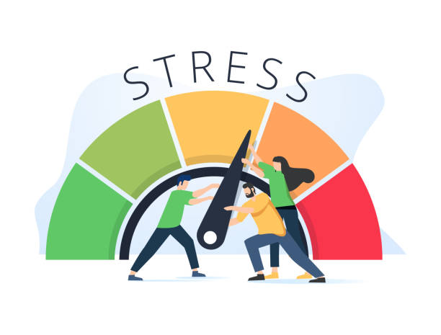
* Building skills and habits

2. Manage Distractions

* Remove all unnecessary UI elements that can not be used for learning.
* Limit the number of game objects to provide the essential only.
* Provide a clean learning/playing space when the child is learning/playing with the 3D Games.
* Some children with ADHD learn well if they are moving or listening to background music. so we add some nice background music.

3. Limit Choices

* To help the child not feel overwhelmed or overstimulated, we offer choices with only a few options
* In most cases, there are only 2 choices to select from.
* This will help the child to feel in control

4. Clarity and specificity

* Clear and specific when asking the child to do something.
* We used clear, brief directions when the players/children needed to do something in the games
* let the child know they have done well in their learning process, we made sure the goals are realistic—small steps are important
* Help the child to not feel confused and to focus

5. Using Goals and Rewards.

* We use a chart to list Scores and playing Results (Final Report Analysis).
* Motivate the child to track positive behaviors. (Score, Coins, Timing)